**Monetization teardown of Love Nikki**

Yuchen Liu

**Step 1: introduction**

Love Nikki is a dress up RPG game with high image quality and interesting story-line.

Players join a journey with Nikki, collect clothes and use them as weapons to battle. Produced by Nikki games, published by Tencent games and Elex, this game provide players with gorgeous outfits, space for free design, and battles for accumulating clothes and currencies. While the main missions players do are collecting various clothes, battles act as the key motivation in the main loop of this game , which require players to collect specific clothes , gain certain currencies ,and enter new story lines to prepare for the next battle. This game is not focusing on how to dress up properly, there’s nearly nothing to do with your aesthetic ability, instead, it requires strategy, time and money. In-game monetization systems have been carefully built in this game, which let players spend out of various reasons.

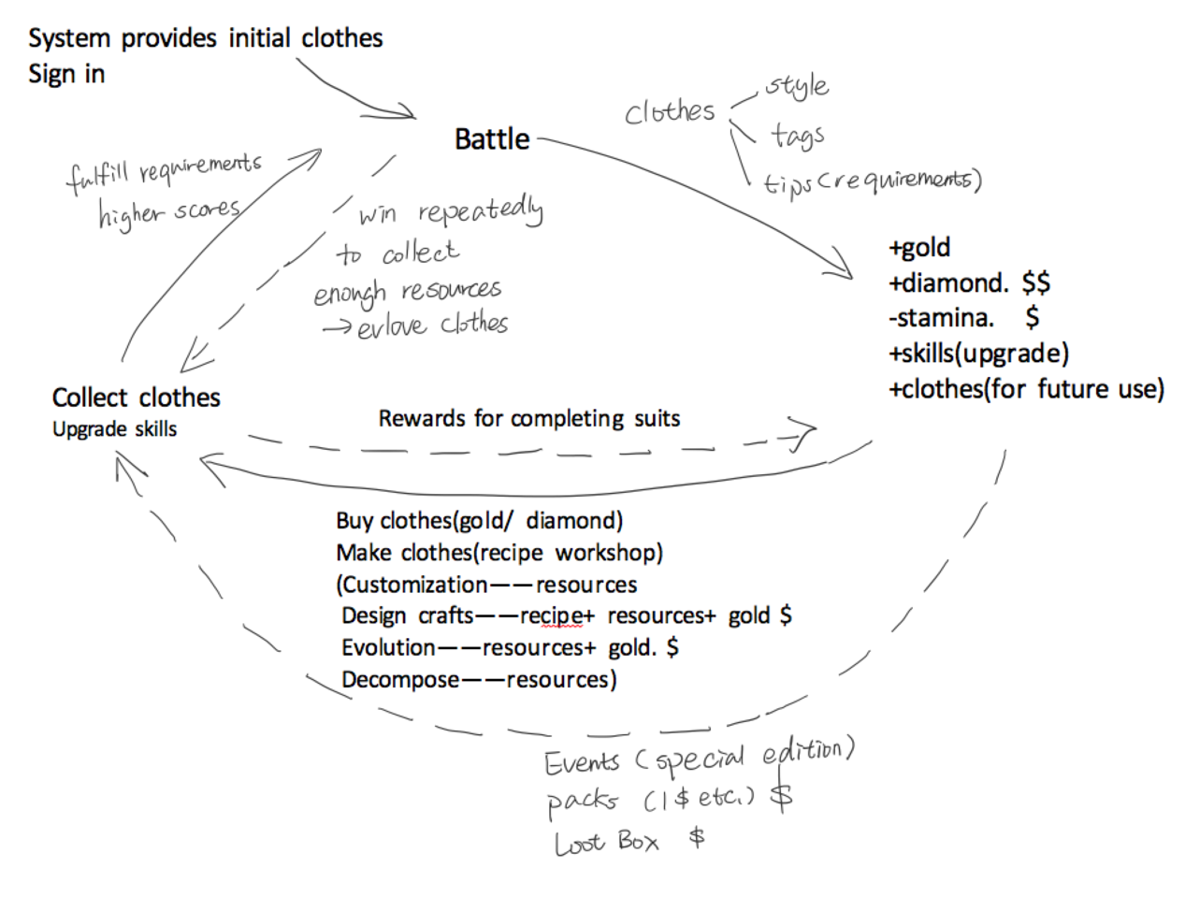

1.1-basic game loop

**Step 2: Actions**

2.1 Battle(PVE+PVP)

As the story line begins, players will encounter with different characters , and select appropriate clothes to battle with them. Clothes should be chosen according to requirements and labels of the levels, and the result of the battles are determined by the scores of both sides’ clothes. The system scores the outfits based on the attributes of the clothes, and the side with higher overall score wins. If right clothes are chosen, the score will be higher; on the contrary, if the clothes do not meet the requirements, it will lead to failure of the battle. Players can use initial clothes from beginner missions to win the first several battles, and continue the following parts with their own effort.

Meanwhile, both PVE(Player VS Environment) and PVP(Player VS Player) dress up battles are available in this game. While level battles within story lines are in PVC form, weekly competition between players called stylist’s arena provide random selected PVP battle opportunities. Besides, all the battles in the game are in one-on-one form.

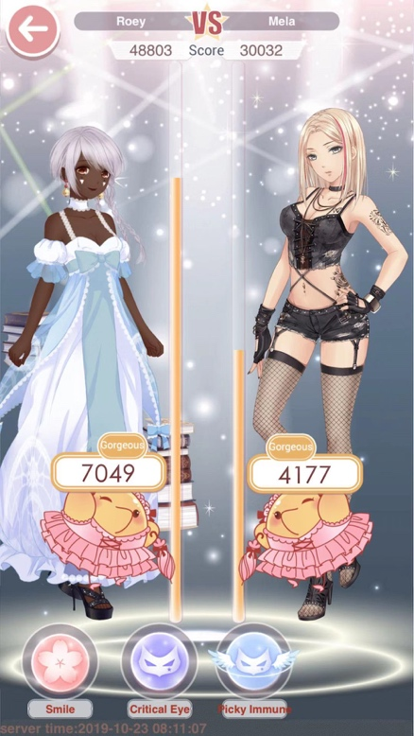 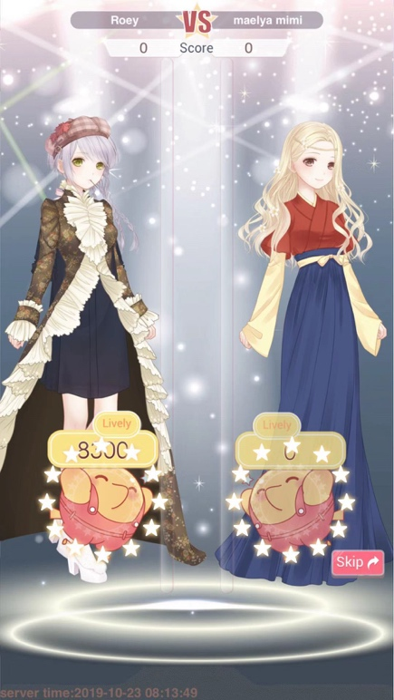

2.1.1 PVE battle 2.1.2 PVP battle

2.2 Clothes making

Receipt workshop provide various functions, including customization, crafting, evolution and decompose. There players can use the features to make special items that add up to the scores in the battle or fulfill the requirements of future levels.

In customization part, players use Dyes to change the color of an object. Not all items can be customized, and will have ‘customizable’ shown on their information card if they can be. To dye an item, you will need Material (which can be earned through decomposition) and Dyes or Patterns.

Under the Design Craft option, players can craft various items as long as they get the craft recipe through in-game stores or loot box. Recipes require between two and four ingredients, including low level clothes got from previous battles, items bought from in-game store and random selections from loot box. Sometimes ingredients must be crafted as well, which increase the difficulty of crafting. Crafting also require cost of certain in-game currency, usually gold.

Players can evolve certain evolvable items to the next level by obtaining a specified quantity of them and pay certain amount of gold. Evolvable wardrobe items may have either one or two evolved stages, the number of lower level clothes required in evolution are different according to the system.

Decompose option enables players to get rid of the additional quantities of the items and break them down into gold and material. If the level of the decomposed clothes is high, chances are that other resources like star coin and special items can be dropped at the same time.

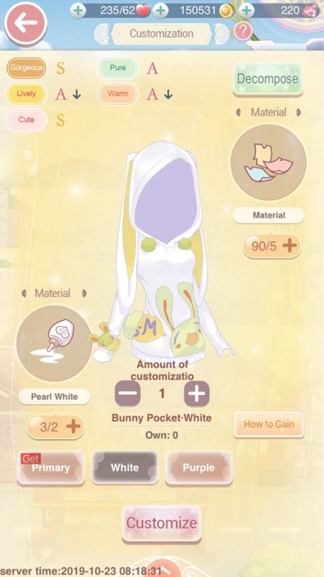 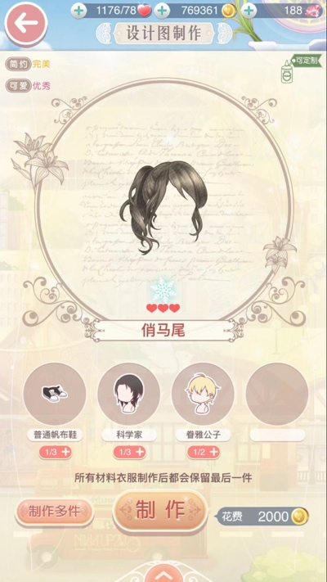 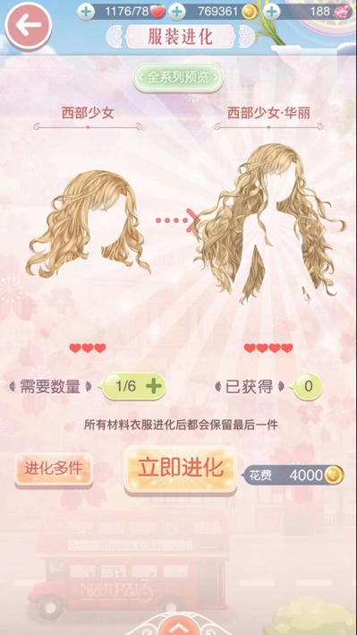

2.2.1 Customization 2.2.2 Crafting 2.2.3 Evolution

**Step 3:Rewards**

Through winning battles, players get in-game currencies ,experience and items as rewards. After regular PVC battle, players usually gain gold and certain clothes. After reaching certain level, for example, entering new chapter, special rewards containing diamond and new recipe would be given. Gold, diamond and other currencies received can be accumulated for buying or making items, and the clothes are usually served as resources in evolution and crafting. As evolution always requires certain amount of clothes, players may need to repeat battles. There are hot key options shown as ‘done1/done10’ on each level, players can press them to done one or ten times quickly as long as the players have won the battle before. Done 10 may cost 10times the stamina used for each battle, and also give all the rewards receive in 10 battles at one time.

Other forms of rewards are also available, like receive diamonds for completing suits, gain gold and stamina for finishing daily missions.

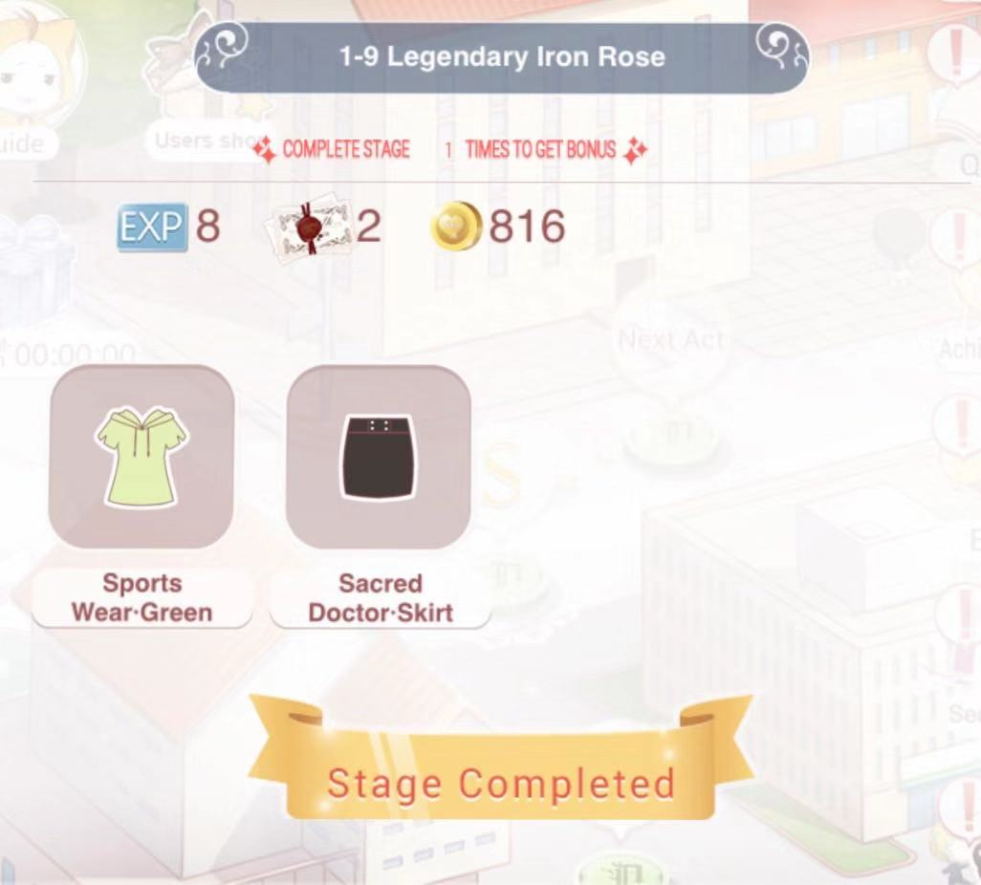 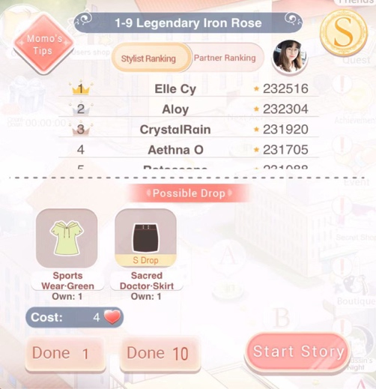

3.1 Rewards for each battle 3.2 The Hot key (Done 1/Done 10)

**Step 4:Expansions**

Through winning both PVC and PVP battles, players can gain certain amount of experience to level up their accounts. Each time when the account get upgraded, the maximum of stamina will increase by one point. For example, a player in grade one only has 60 amount of stamina at most, but a ten grade player can have a maximum of 70 stamina, which motivate players to play harder.

There are skills which can help increase the scores of the outfits in the battle, such as Smile, charming, critical eyes, picky immune, picky bounce, etc. Each of them has different functions. Through winning battles and increase in game level, higher levels of skills are unlocked . For example, ‘critical eyes’ is introduced to players after they entered level 1-5, which can decrease the opponent’s score immediately by at least 13%. Players can also use gold to upgrade the skills. In the case of ‘critical eyes’, it takes 103500 gold to be upgraded from level 8 to the max level 9, and a level 9 ‘critical eyes’ can decrease 21.3% of opponents’ score during battles.

As players continue to battle and upgrade, the difficulty of the game will also increase accordingly. The clothes in the advanced level often require a lot of resources for crafting and customization, which makes it difficult to manufacture and provide players with more challenges.

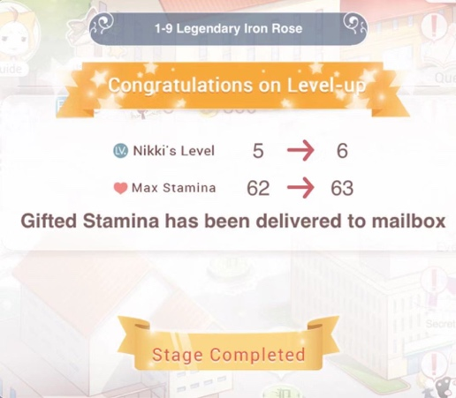 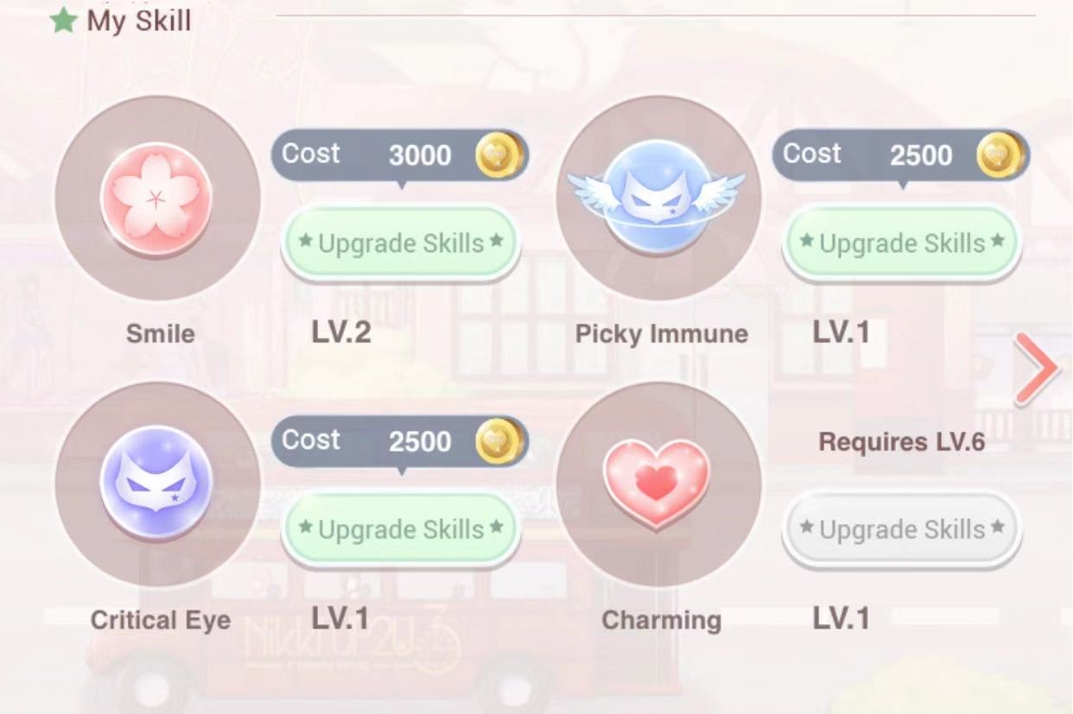

4.1 Account level up 4.2 Skills

**Step 5:In-game currencies**

The main currencies in the game are gold , diamond and starlight coins. There are also other in-game currencies like suzaku bell and karma crystal, but they only appear in loot box and certain events.

Gold is the most common currency in the game, mainly obtained by winning battles and completing missions. Gold has various functions, for example, they can be used to buy clothes in stores, craft items , evolve clothes, upgrade skills, etc. Gold can be used in almost all occasions, but under most conditions it can only be obtained by in-game actions, and cannot be converted or traded directly with real money.

  Diamond is the "high-level currency" in the game. It is more widely used than gold and also more difficult to be obtained. Diamond is the only in-game currency that can be directly linked to the real currencies. Players can recharge certain amount of money to get the corresponding number of diamonds. Although the player can also get the diamond by taking tasks, the number of diamonds got from playing is small, which make it more related to recharging. In addition to the functions of gold , diamonds can also be used for the loot box lottery, gaining additional battle opportunities in events, and all the other ways that can accelerate the game process. Diamond also acts as ‘general equivalent’ with some other in-game currencies, since players can use diamonds to purchase gold and stamina, while in the loot box, 1500 diamonds equals to 10 loot box currencies.

Starlight coins are used to buy crafting recipes or color dye. The only way to obtain star coin is to battle in the Stylist's Arena. Players can gain three star coins per loss and five per win.

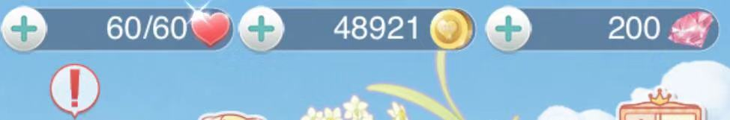

5.1 stamina, gold, diamond

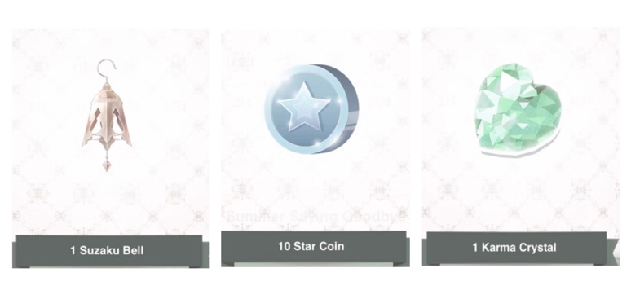

5.2 starlight coin and loot box currencies



5.3 Recharging diamond with real money

**Step 6 :In-game stores**

There are mainly two in-game stores ,one is the common store, the other is the store of starlight. The common store provide players with various kinds of items, ranging from hair, dresses, tops and bottoms, accessories, shoes and even makeup. Each of them has different price according to its label and rareness. Players can use either gold or diamond to purchase items. Some rare suits are only temporarily available in the common store, and some items would have discounts on special days.

The store of starlight serve as the exchange for Stylist's Arena, where players can trade Starlight Coins for Dyes, Materials, and Recipes. The tabs in store of starlight are the same with the common store, but the difference is that the store of starlight do not sell clothes directly. Instead, players should continue collect resources and use the things bought in the store of starlight in the recipe workshop to gain the items.

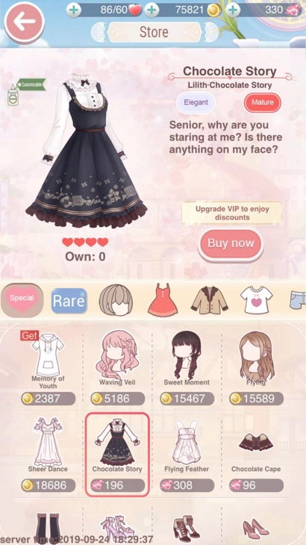 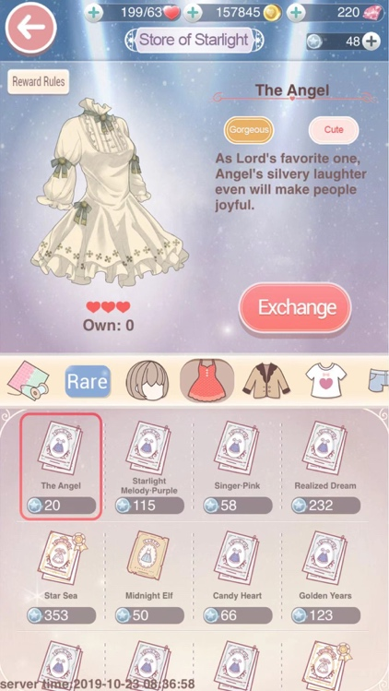

6.1 The common store 6.2 The store of starlight

**Step 7: Events**

Regular in-game events under different theme are held every month, providing missions to win special edition, which are both beautiful and useful in levels later on. But while gaining small pieces of the clothes in events is rather easy, complete the suits in limited time usually turns out to be tough work require either time or money. Players can charge money to buy diamonds and stamina, skip some missions and increase the rate of getting the gorgeous dresses. Also, events help retrieve the losing players while costing the diamonds and gold accumulated by players through actions, which overall increase the need of recharging money repeatedly.

Holding Events which cooperates with other IP or brands serve as a common way to attract certain players and motivate playing. Specific events are held according to different regions in order to gain better result. For example, the international version of Love Nikki co-branding with Barbie recently, while the Chinese version held events about Mid-autumn Festival.

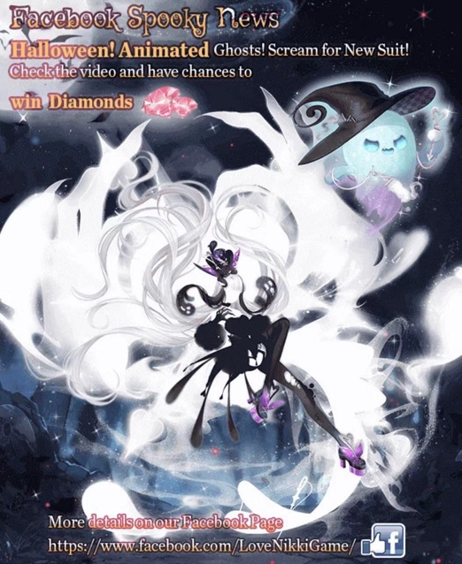 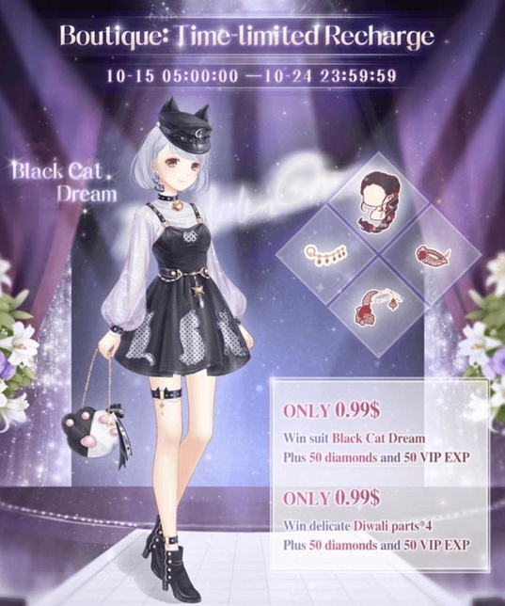

7.1 Events in international version

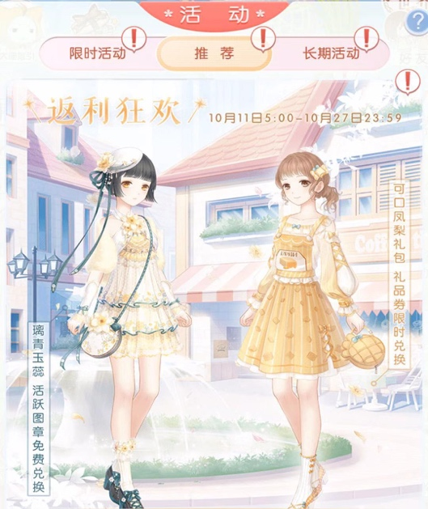 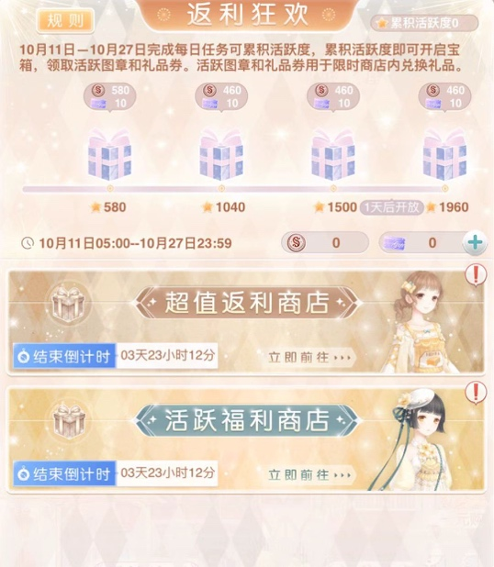

7.2 Events in Chinese version

**Step 8: Packs**

Packs also act an important role in the monetization system of Love Nikki. Generally, packs are special in-game reward packs, which can be purchased directly with real money. Most of the time, packs are more favorable and cheaper than the common recharging way (buying diamonds), so while packs are more welcomed and attractive to players, there are often restrictions on the number of purchases.

Various types of packages are provided in the game, such as beginner’s pack, diamond pack, gift pack, return pack and so on. Packs can contain many kinds of rewards, including clothes, in-game currencies, resources, and more. The packs can help player to speed up process of playing, adapt to the game as a beginner, or catch up with other players as a returning player.

In addition, all the packs in this game share a same feature, which is all of them can be bought at a relatively low price. Most of the packs are under 5 dollars, and since the amount of money required each time is not high, it gradually urges people to pay without hesitation repeatedly .Meanwhile, low price is prompting young player whose age is under 18 to spend money.

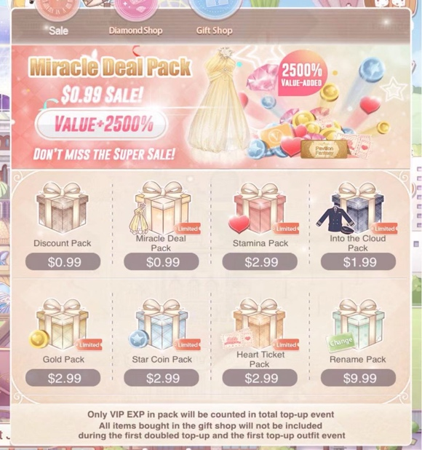 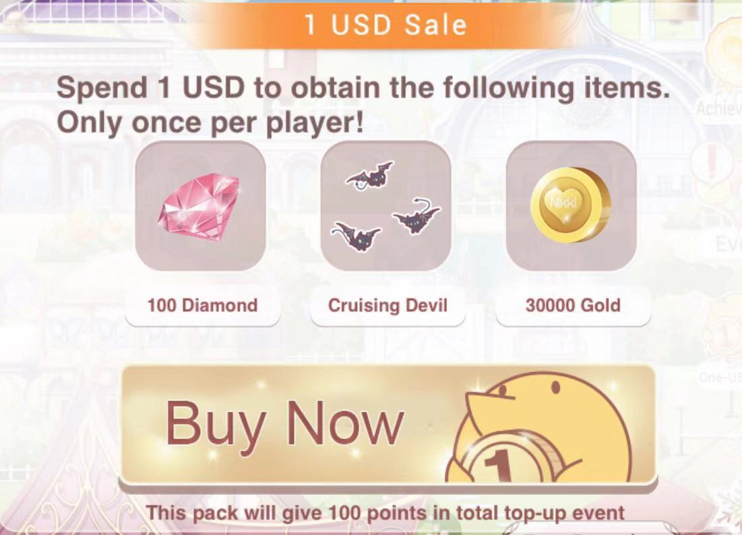

8.1 Common packs 8.2 The beginner’s pack

**Step 9: Loot box**

Similar to other games, Love Nikki also have loot box called ‘Mystery House’. Players can spend either gold or diamond to buy chances of rolling loot box to gain random items. There are six different styles of loot boxes, ranging from traditional Chinese style to western fairy tale style. A free opportunity once or twice a day is provided here, in an effort to attract players’ interest and encourage players to form a habit of using loot box. Players can use gold or diamond to roll the loot box 10 times or 100 times at a time, and receive randomly dropped items of 1 to 5 stars rarity. The more you buy once, the more likely you are to have rare items. Each time of rolling will also accumulate loot box currencies, which can be used directly to exchange rare items. However, the loot box usually costs more money. Player needs to spend 1,500 diamonds to buy ten chances, or 270,000 gold to buy 100 chances. It can be said that it is the highest single in-game currency consumption in this game. Loot box and the items dropped are also updated regularly with in-game events, and the new random collections from loot box often lure players to recharge .

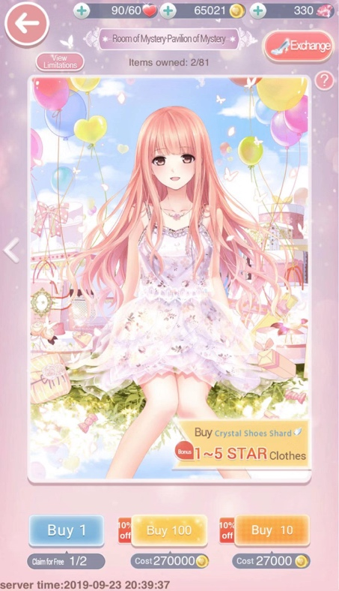 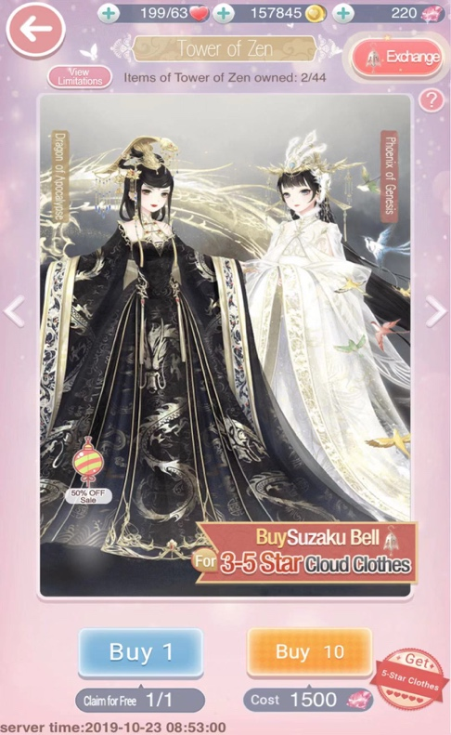

9.1 Different styles of loot boxes

**Step 10: Daily missions**

Daily missions of this game can be mainly concluded into two parts. One is the ‘daily quest’, and the other is daily sign-in tasks.

In the ‘daily quest’, various small missions are given to players to complete each day, and it will reward players with stamina ,starlight coin ,gold and diamond. It seems totally about in-game actions, but two of the daily missions are always about recharging, like ‘recharge monthly card-tier ’ or ‘recharge to activate v privilege’. In order to complete all the tasks of the day, chances are that players are more likely to do recharge.

The sign-in tasks repeat monthly, enable players to sign in everyday to receive one reward from gold, diamond, stamina ,starlight coin and clothes. If succeed in 30-day consecutive sign-in, players can also get a special set from the tasks. But if player miss one of the day, gold or diamond is needed to claim the reward of the missing day.

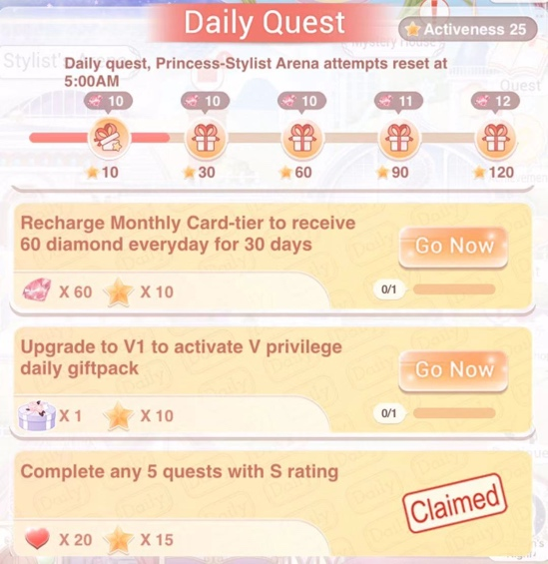 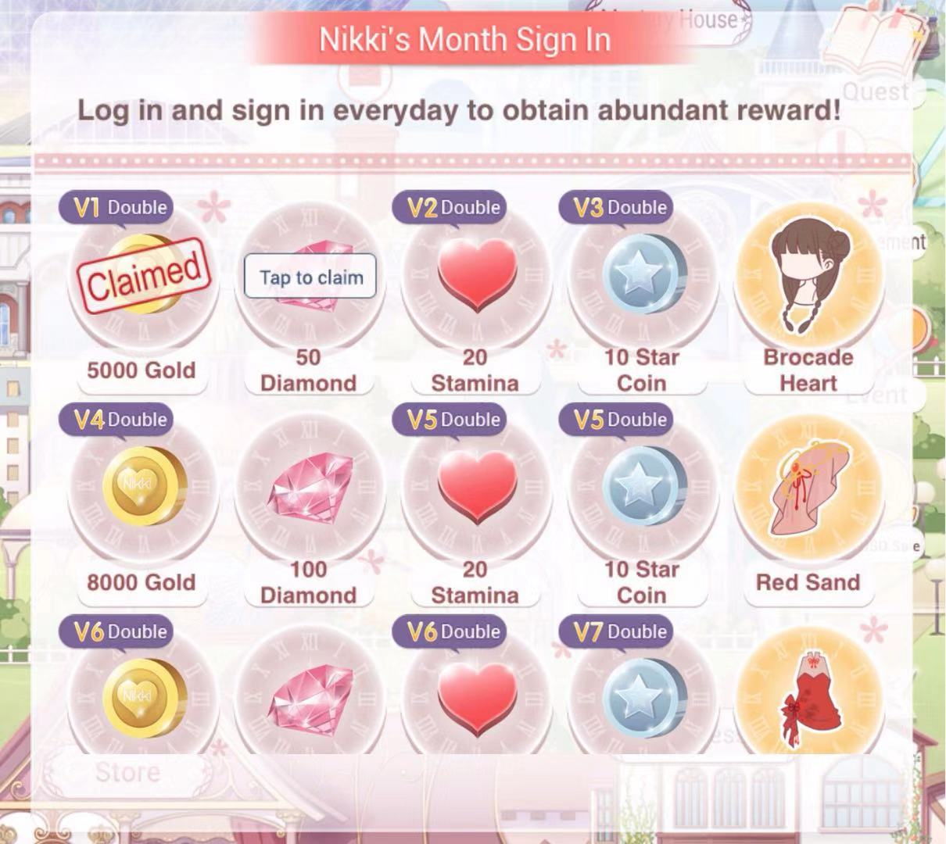

10.1 Daily quest 10.2 sign-in task

**Step 11: V privilege**

The game gives each player who recharged money a different level of v privilege. V privilege is divided into 1 to 10 levels. The more you recharges, the higher the v level, and the more privileges there will be. Certain amount of money recharged for different levels have been determined by the system, such as ‘recharge 10 diamonds to become v1’, and ‘recharge 100 diamonds to obtain v2’.

After becomes ‘v player’, the system will first reward the player with a certain amount of in-game currency and special clothes. At the same time, v players can get more rewards in a variety of daily tasks and events. For example, in daily sign-in, players with v privilege can double some of the rewards, and some of the rare rewards can only be doubled under v10, which motivate players to recharge more in order to gain rewards faster.

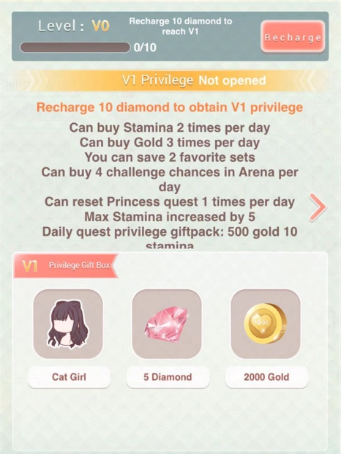 

11.1 V privilege and double daily rewards

**Step 12: Conclusions**

Overall, Love Nikki is a game with a large number of users and has been an influential topic in China from 2015 to 2016. Its in-game story lines and images are very well-made, and as the first competitive dress-up mobile game in the same period, it has once led the trend of female-targeted game for quite a while. The monetization system built in this game also contains a lot of strategies which can effectively attract a large amount of players.

However, after four years of releasing, its problems are constantly being exposed. Since the players are mainly young females, its key monetization strategy lies in repeated small recharges by a large number of users . But now a lot of users have been lost, and the too high level of difficulty often makes players been stuck in one level for a long time, even if they have recharged money. This usually disappoints the players and becomes one of the reasons of them to leave this game. Most importantly, its core game mode is relatively simple, the form of dressing up has gradually been tired of the players, while there is still no better alternative new game mode for the moment. I think this is probably the biggest problem with Love Nikki and other similar types of dress-up games.